
VitalZ Counselling
First Session Orientation

VitalZ Counselling
Zara Faiz
zarafaizi@hotmail.com

Thank you for choosing to work with me. I hope I can earn your trust and I look forward to walking alongside you on this journey.

Please print and complete the required paperwork prior to your first session. Completing this paperwork allows us to spend more time on communication rather than administrative, issues during the first session.

- Welcome to Counselling
- Intake - Individual or the Intake – family, couple
- Email & Text Messaging Correspondence
- Informed Consent
- Payment Method / Finances

Some things to know and think about prior to our first session:

- I will collect the paperwork, clarify the importance of confidentiality, answer all your questions, and address any concerns you might have about the paperwork or counselling in general.

- It is helpful for me to know about particular symptoms related to your reasons for seeking therapy. It can help us narrow our work and help me understand some of the challenges we might focus on.

- It is particularly helpful for the therapeutic process if you bring a list of goals for your time in counselling. Please be specific if at all possible. This will help me better understand what ways counselling might be helpful and how your life might be different with counselling.

Name: Preferred Pronoun (may decline):

Please place a checkmark in the boxes that correspond to current problems you are having:
Feeling sad Loss of pleasure Loss of interest in activities Anxiety or excessive worry Difficulty controlling worry Difficulty concentrating Problems with memory
Fatigue or loss of energy Problems sleeping Frequent irritability Racing thoughts Risky behaviors Distractibility Decreased need for sleep Excessive spending Frequent angry outbursts Talking excessively Feeling restless or “hyper” Problems with appetite Negative feelings about yourself
Feelings of guilt Feelings of hopelessness Tension or muscle tightness Feeling bored Feeling “different” from others Lack of control over life Problems with relationships Lack of self-esteem Problems with sex / sexuality Body Image Thoughts of harming others
Drug or alcohol problems Thoughts of suicide or self-harm Shyness Confusion about career choice
Lack of direction in life Need for more fulfilling life Feeling stagnant Feelings of helplessness Social anxiety Problems with trust Problems with identity

Of all the problems you checked, please underline the three that are the most troublesome at this time. What do you hope to gain by coming to therapy?
___________________________________________________________________________________
___________________________________________________________________________________
____________________________________________________________________________________

Name and pronoun you prefer is used (You may decline): ____________________________________
Address:___________________________________________________________________________
Phone Number: Cell:________________________ Home: _________________________________
Email address: ______________________________________________

Can I contact you at this number? Y ___ N ___ Can I contact you at this Email: Y _____ N ______

Can I leave messages at this number? Y ____ N ____
Can I leave messages with third parties at this number? Y____ N____

Can I text at this number: Y ______ N _____

Do you regularly check messages? Email: Y: ___ N: ____ Phone: Y: _____ N: _____

For whom is the counselling service: ___________________________________________

Age:__________ DOB: ____________________

Do you have children?: Y ______ N ________ If so, how many and what are their ages?
______________________________________________________________________________

Emergency Contact:______________________________________________________________
Relationship to you: ______________________________________________________________

Emergency Contact phone number and email address: ______________________________________

What is/are the main issues bringing you to counselling? ________________________________________________________________________________________________________________________________________________________________________________________________________________________________________________________________________________________________________________________________________________________________________________________________________________________________________________________________________________________________________________________________________________________________________

What are your main goals for counselling? ________________________________________________ ______________________________________________________________________________________________________________________________________________________________________

Are you on any medications we should be aware of? ________________________________________

Do you have any serious allergies I should be aware of? _____________________________________

How did you find out about my services?
Google Search _____________________________________ / Psychology Today ________________
Referral (Name) ____________________________________________________________________

GOALS FOR THERAPY: (List all and use back if required)
1.

2.

3.

Do you have any other significant medical problems that I should be aware of?

Is there a history of substance abuse that might be helpful to know?

Are you taking any medications?

How were you referred to our office?

How did you find out about my counselling services?

Please indicate any previous counselling experience?
______________________________________________________________________________________________________________________________________________________________________

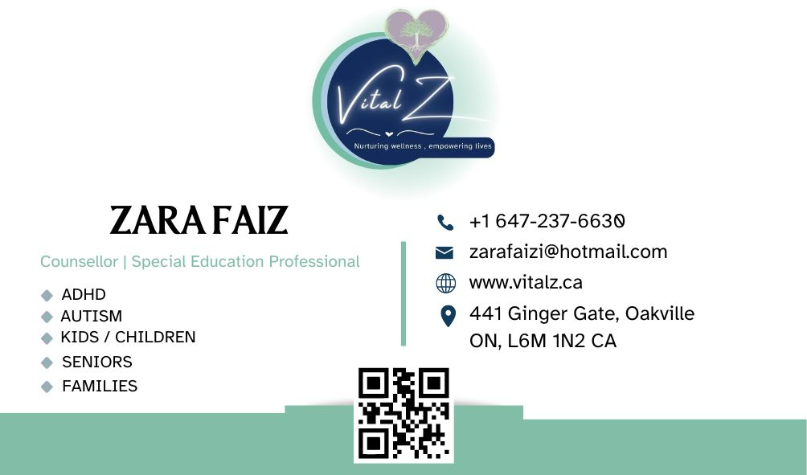
PLEASE FILL OUT THE FORM AND SEND IT TO
zarafaizi@hotmail.com

